Christian Van Loon

2/5/2021

Fsw-140

**The New Avengers**

1. Show all of the information on the Avengers.

a. Query: **SELECT** * **FROM** avengers

b. Columns:

URL, name, appearances, current, gender, probationaryIntro, fullAvengersIntro, year, yearSinceJoining, honorary, death1, return1, death2, return2, death3, return3, death4, return4, death5, return5, notes.

c. Expected row count: **171.**

d. Screenshot

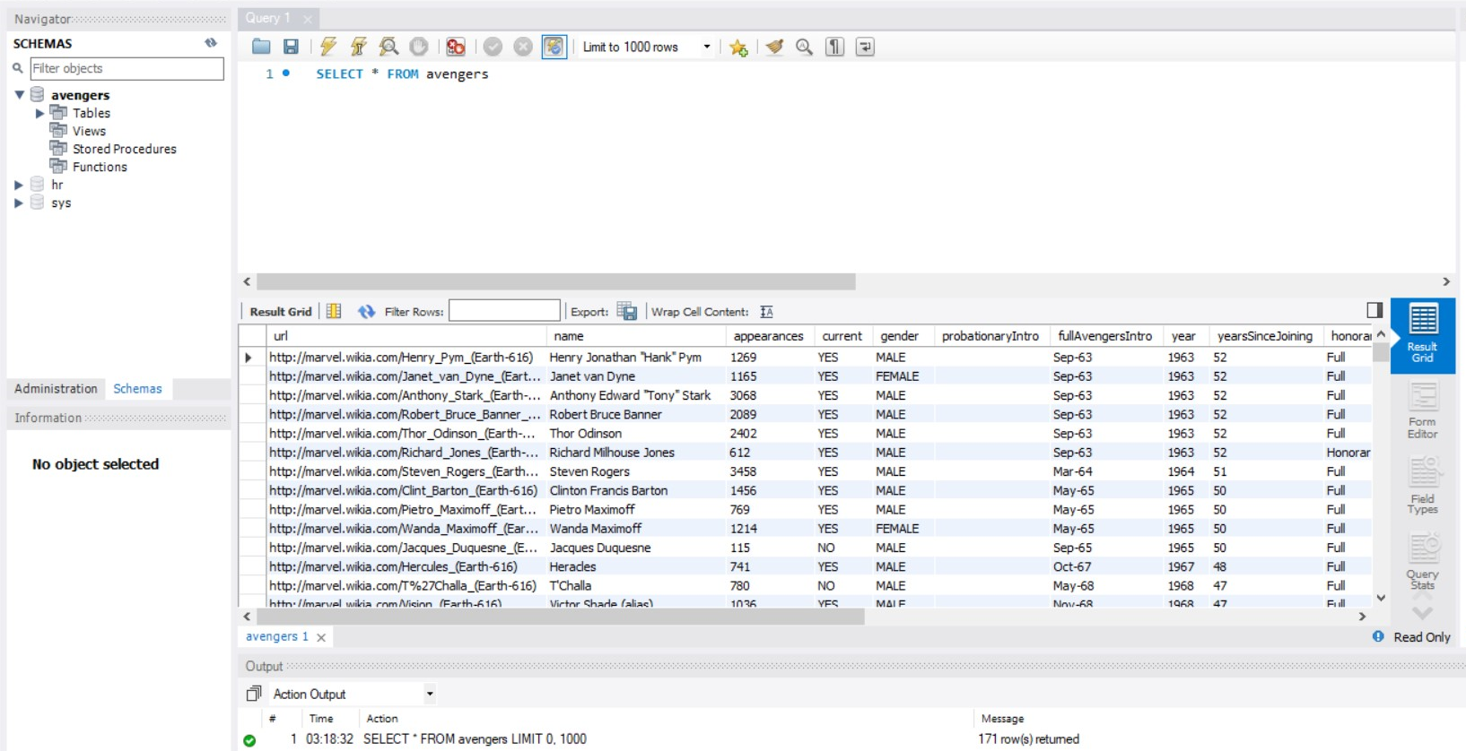

1. Create a new table with information from another super hero group [can be imported from elsewhere or fictitious]. Make sure there is an appropriate header and must be at least 30 rows.
2. a. Query: SELECT * FROM dc_heroes;
3. b. Columns: page_id, name, urlslug, id, align, eye, hair, sex, gsm, alive, appearances, first appearance, year.
4. c. Expected row count: 2709 rows added.
5. d. Screenshot

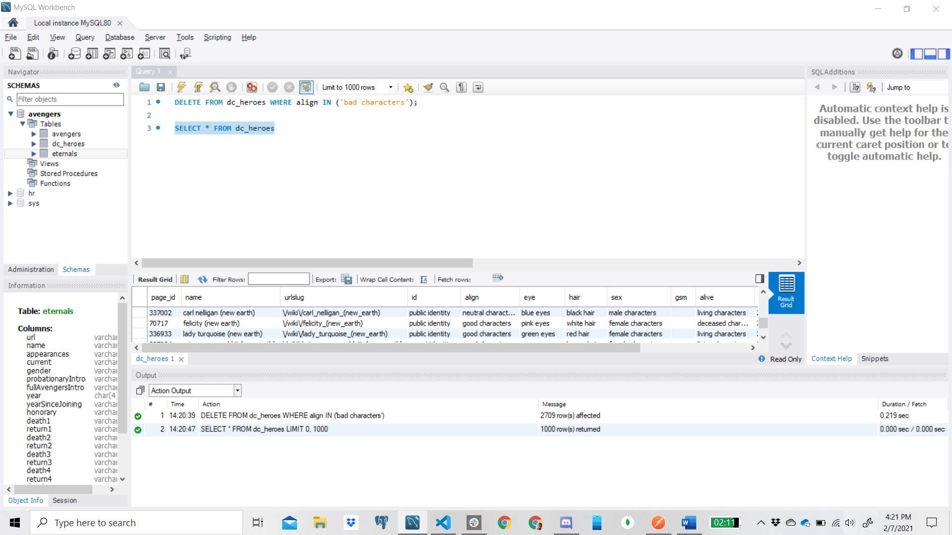

1. Add a column to your new table (the new superheroes) for those who are interested in joining the Avengers. Make this be randomly assigned.

ALTER TABLE dc_heroes

ADD COLUMN interested VARCHAR(3) AFTER name;

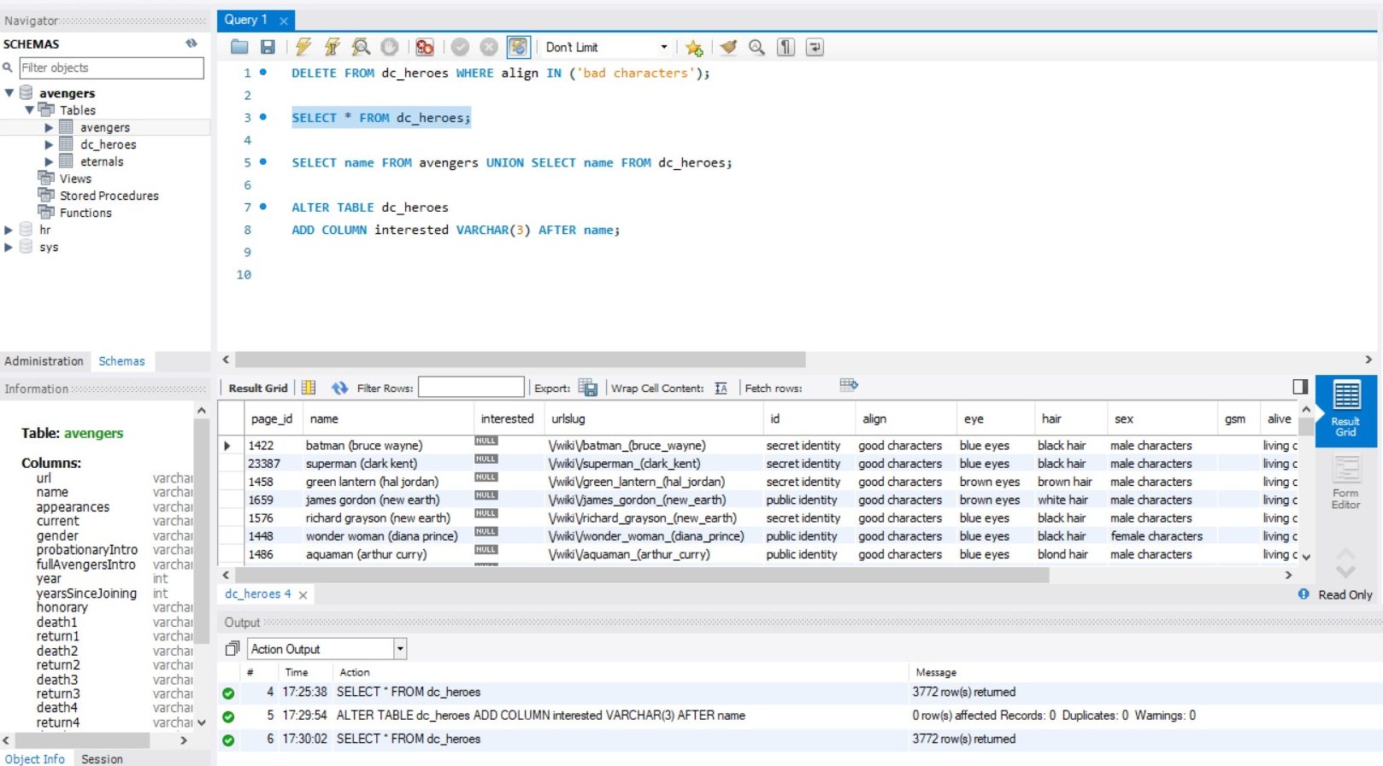

1. Add a column to your new table (the new superheroes) for their favorite Avenger (have it randomly choose between Anthony Edward "Tony" Stark, Robert Bruce Banner, & Victor Shade).

ALTER TABLE dc_heroes

ADD favorite varchar(50)

AFTER name;

UPDATE dc_heroes SET favorite = ELT(0.3 + RAND() * 3, 'Anthony Edward "Tony" Stark', 'Robert Bruce Banner', 'Victor Shade')

Needed a fix:

ALTER TABLE association

ADD COLUMN interested VARCHAR(3) AFTER name;

UPDATE association SET interested = ELT(ROUND(RAND() + 1, 0) , 'YES', 'NO');

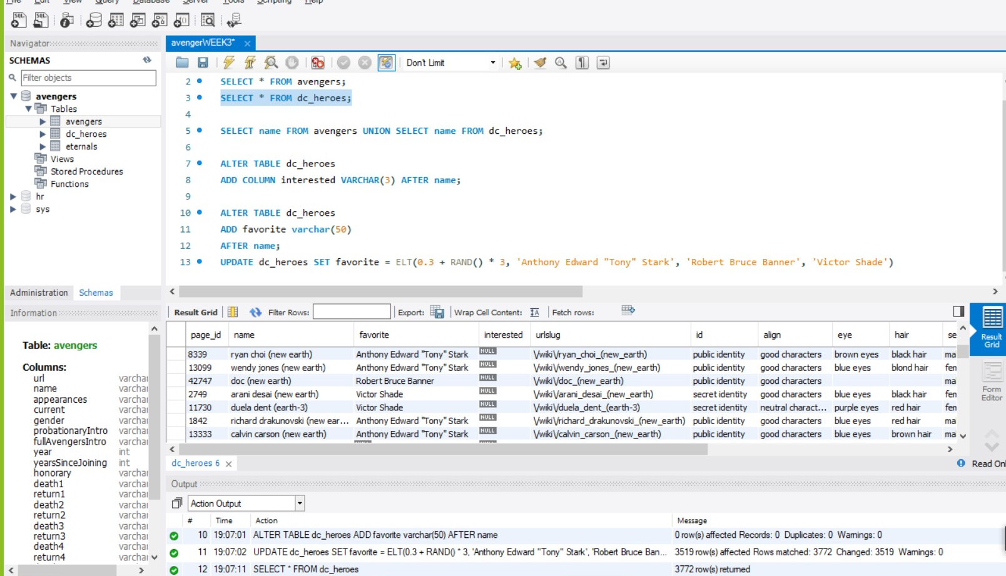

1. Create an association between the two tables for who is interested in joining the Avengers.

SELECT name FROM avengers UNION SELECT name FROM dc_heroes

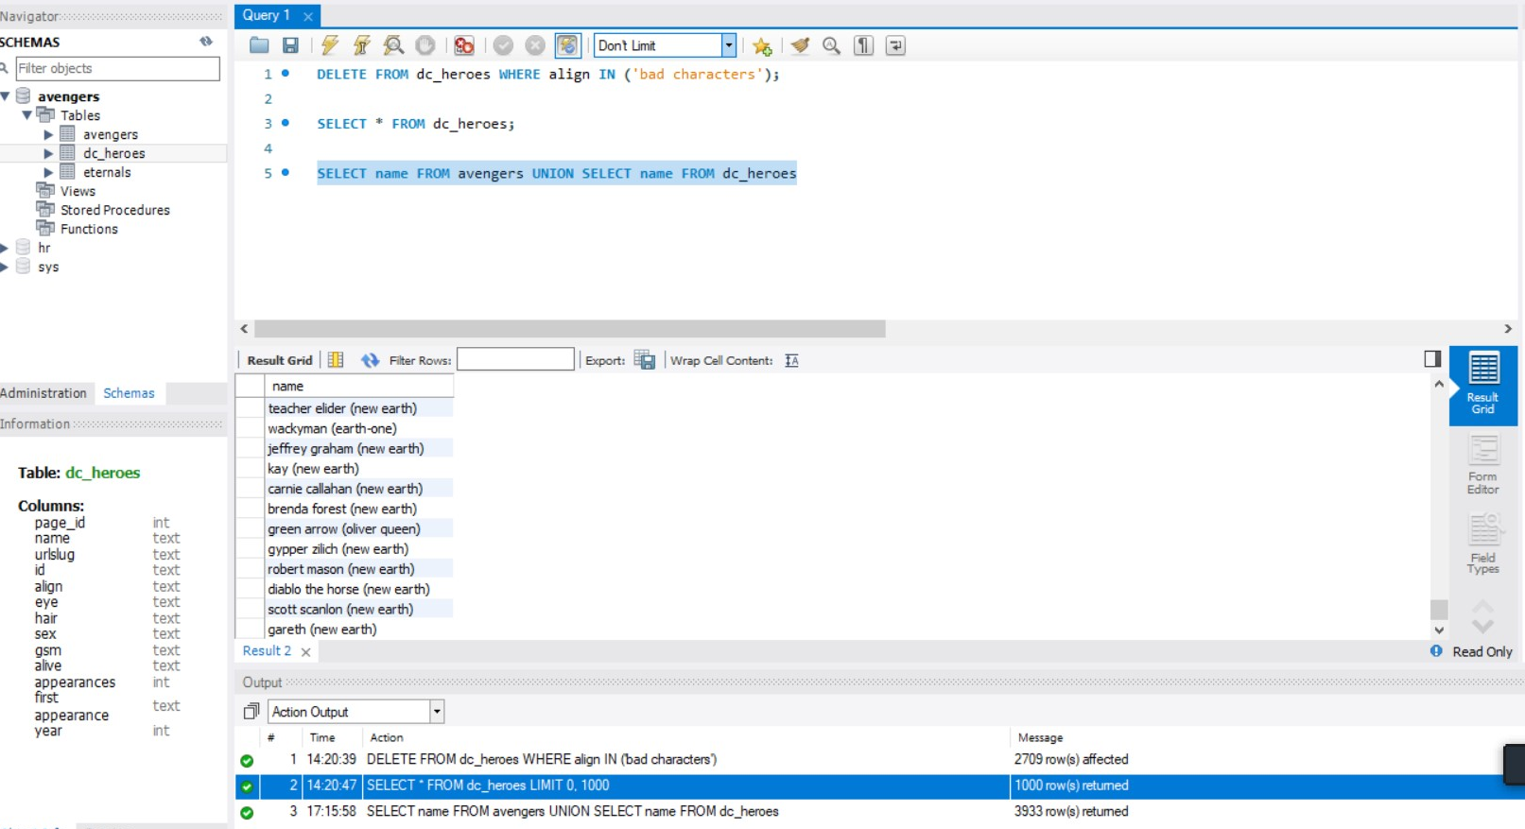

1. Show your association and create a new table for that association.

CREATE TABLE IF NOT EXISTS association

AS SELECT name FROM avengers UNION SELECT name FROM dc_heroes;

SELECT * FROM association;

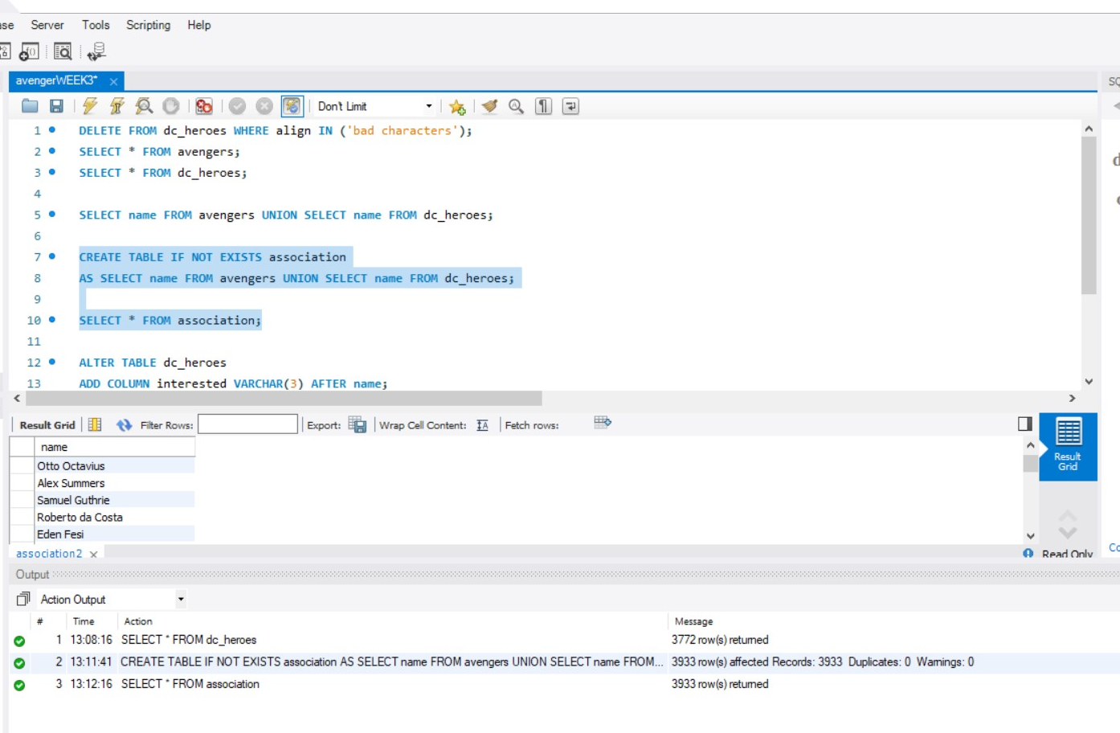

1. List all Avengers who have more than 1000 appearances in alphabetic order.

SELECT name, appearances from avengers WHERE appearances > 1000 ORDER BY name desc;

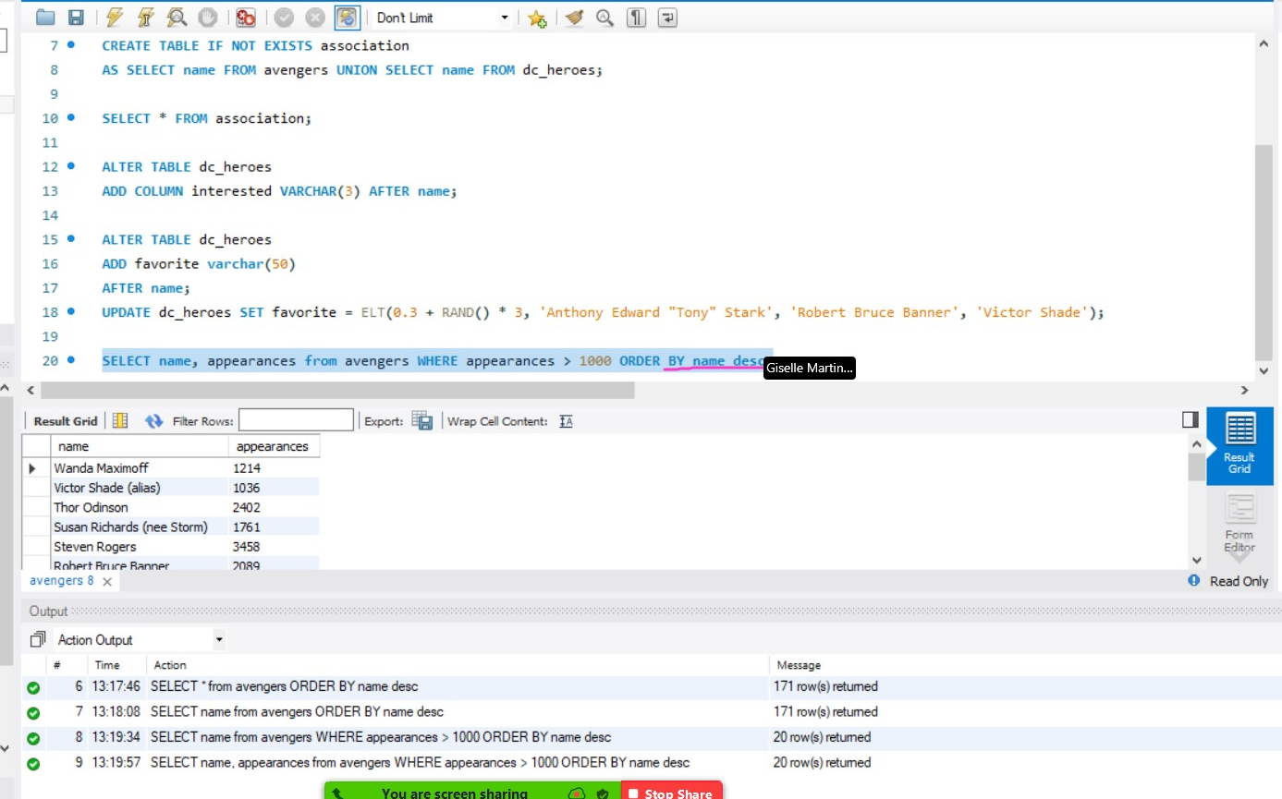

1. What Avengers do not have more than 1000 appearances?

SELECT name, appearances from avengers WHERE appearances < 1000 ORDER BY name desc;

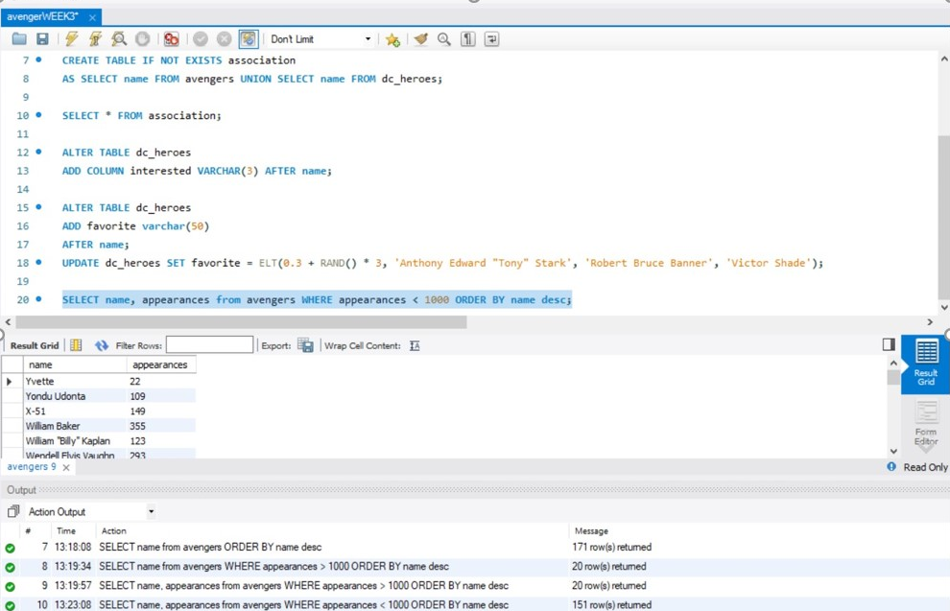

1. Not more than 500?

SELECT name, appearances from avengers WHERE appearances < 500 ORDER BY name desc;

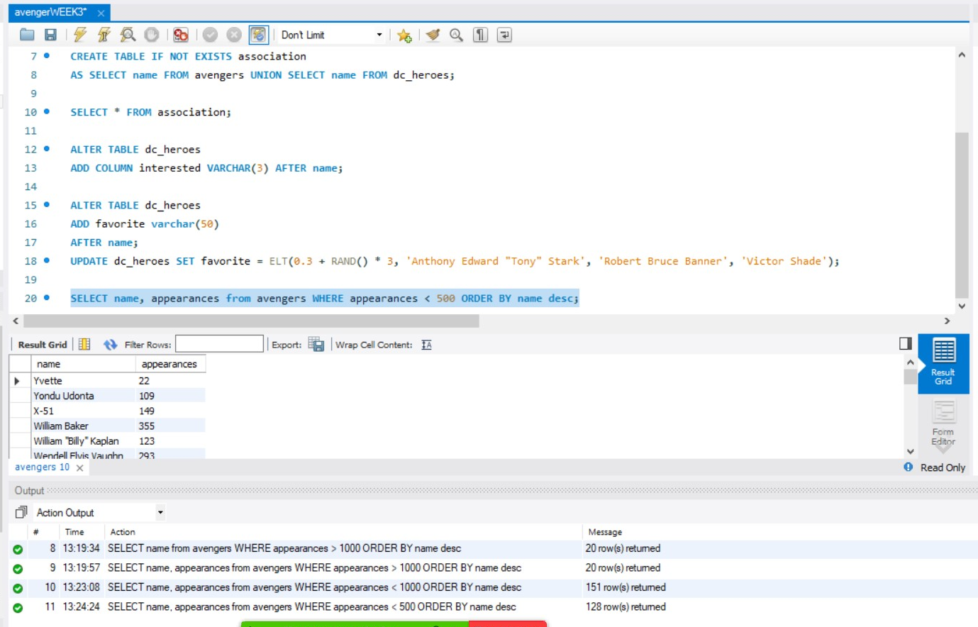

1. Not more than 50?

SELECT name, appearances from avengers WHERE appearances < 50 ORDER BY name desc;

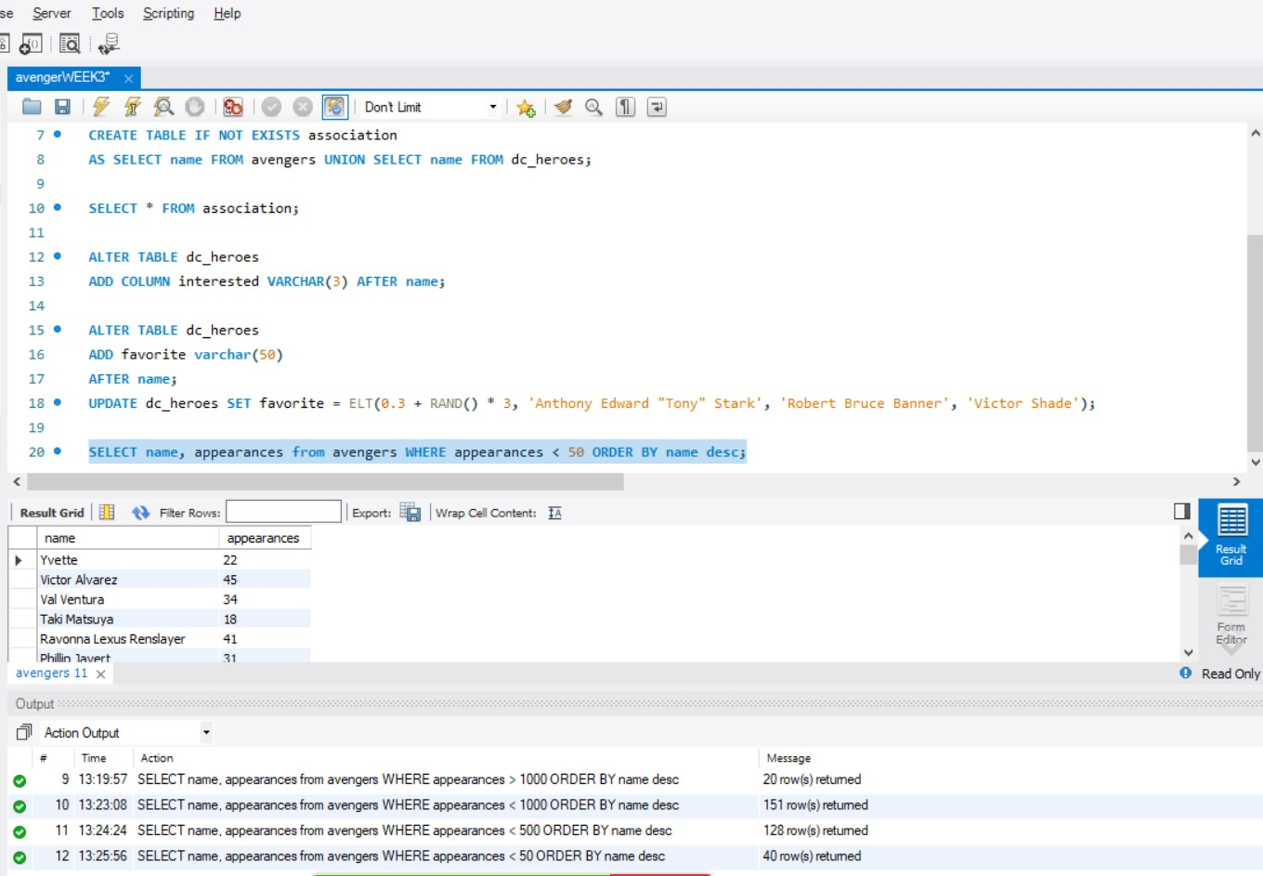

1. Not more than 50 and female?

SELECT name, appearances, gender from avengers WHERE appearances < 50 AND gender = "Female";

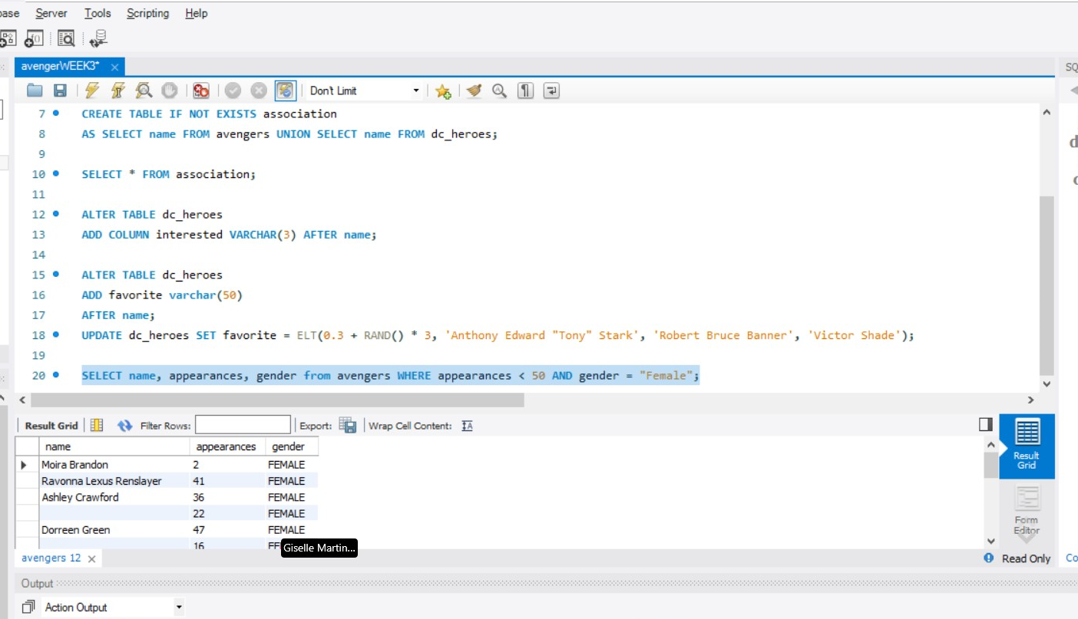

1. More than 150, male, and are full members?

SELECT name, appearances, gender, honorary from avengers WHERE appearances > 150 AND gender = "Male" AND honorary = "Full";

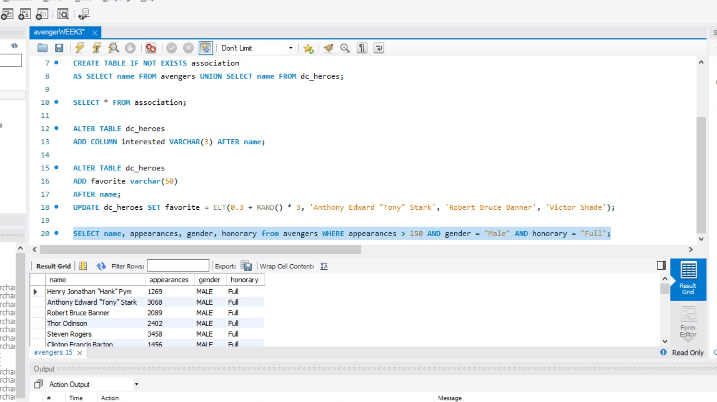

1. Write a function that can add a new superhero to the Avengers if they are interested in becoming an Avenger and if their favorite Avenger is Victor Shade.

DELIMITER //

CREATE FUNCTION addAvenger(added_name text, hero_limit INT ) RETURNS INT deterministic

BEGIN

INSERT INTO avengers(name)

SELECT distinct name FROM association

WHERE favorite = added_name

AND interested = "YES" LIMIT hero_limit;

RETURN 1;

END

//

// DELIMITER ;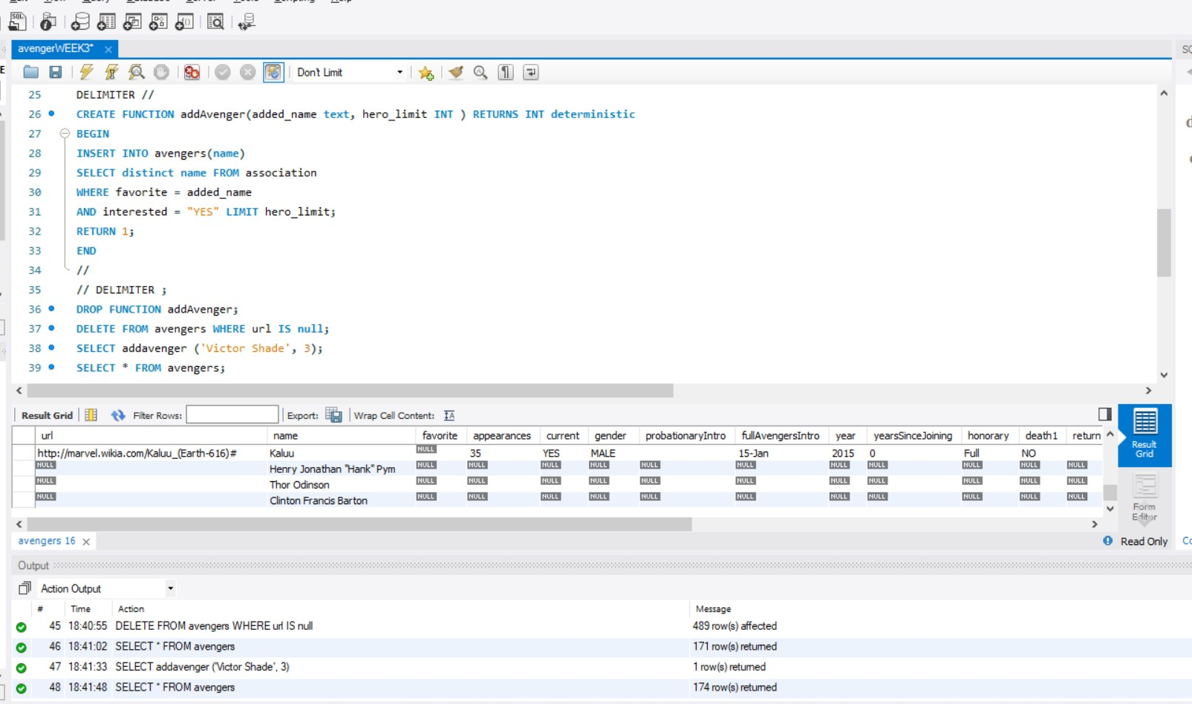

1. Write a "totalRecords" function that counts the total amount of records(rows/entries) in each table.

DELIMITER //

CREATE FUNCTION totalRecords () RETURNS INT DETERMINISTIC

BEGIN

DECLARE total int;

SELECT DISTINCT count(*) FROM avengers INTO total;

RETURN total;

END

//

//DELIMITER;

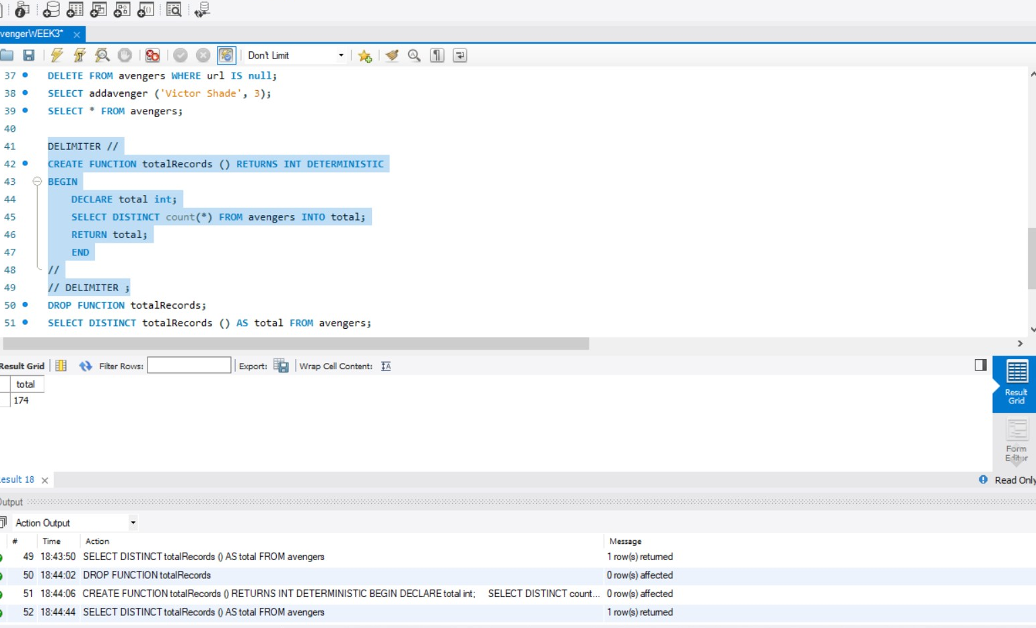

1. Call your totalRecords function (created in step 14 above) on the avengers table. What is the output?

SELECT DISTINCT totalRecords () AS total FROM avengers;

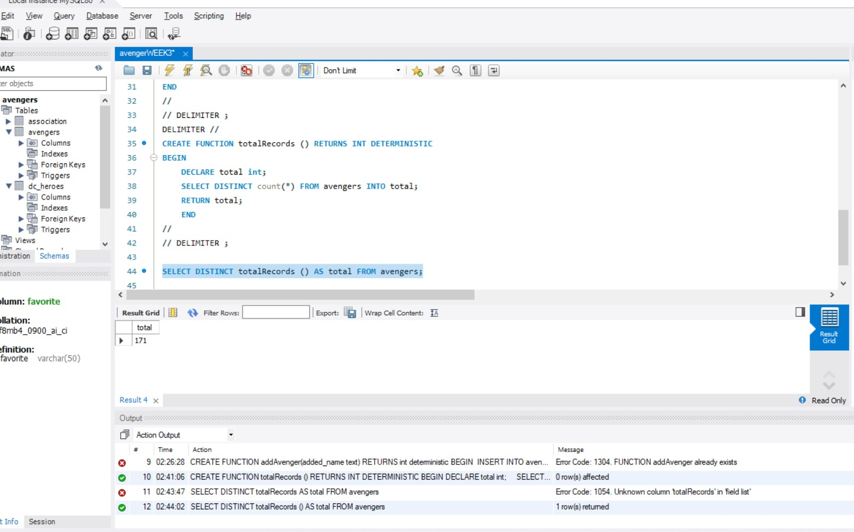

1. There is room for 3 new Avengers so invoke your newly created function (in step 13 above) 3 times to add 3 new members to the Avengers.

SELECT addAvenger ('Anthony Edward "Tony" Stark', 1);

SELECT addAvenger ('Robert Bruce Banner', 1);

SELECT addAvenger ('Victor Shade', 1);

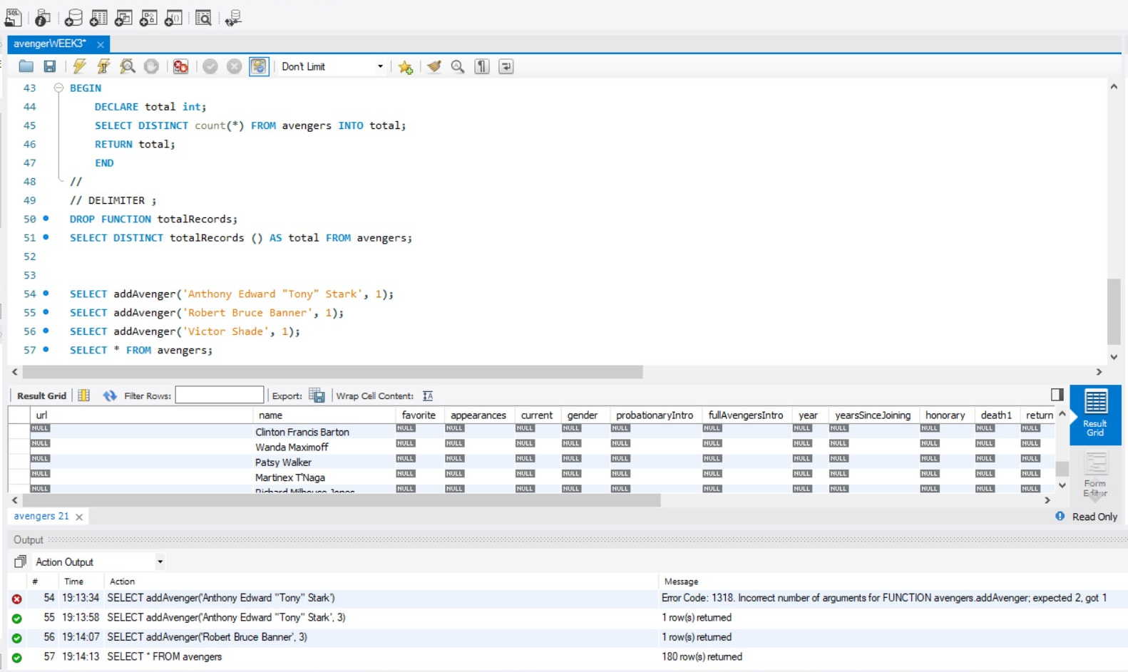

1. Show that the addition of new members was successful.

SELECT * FROM avengers;

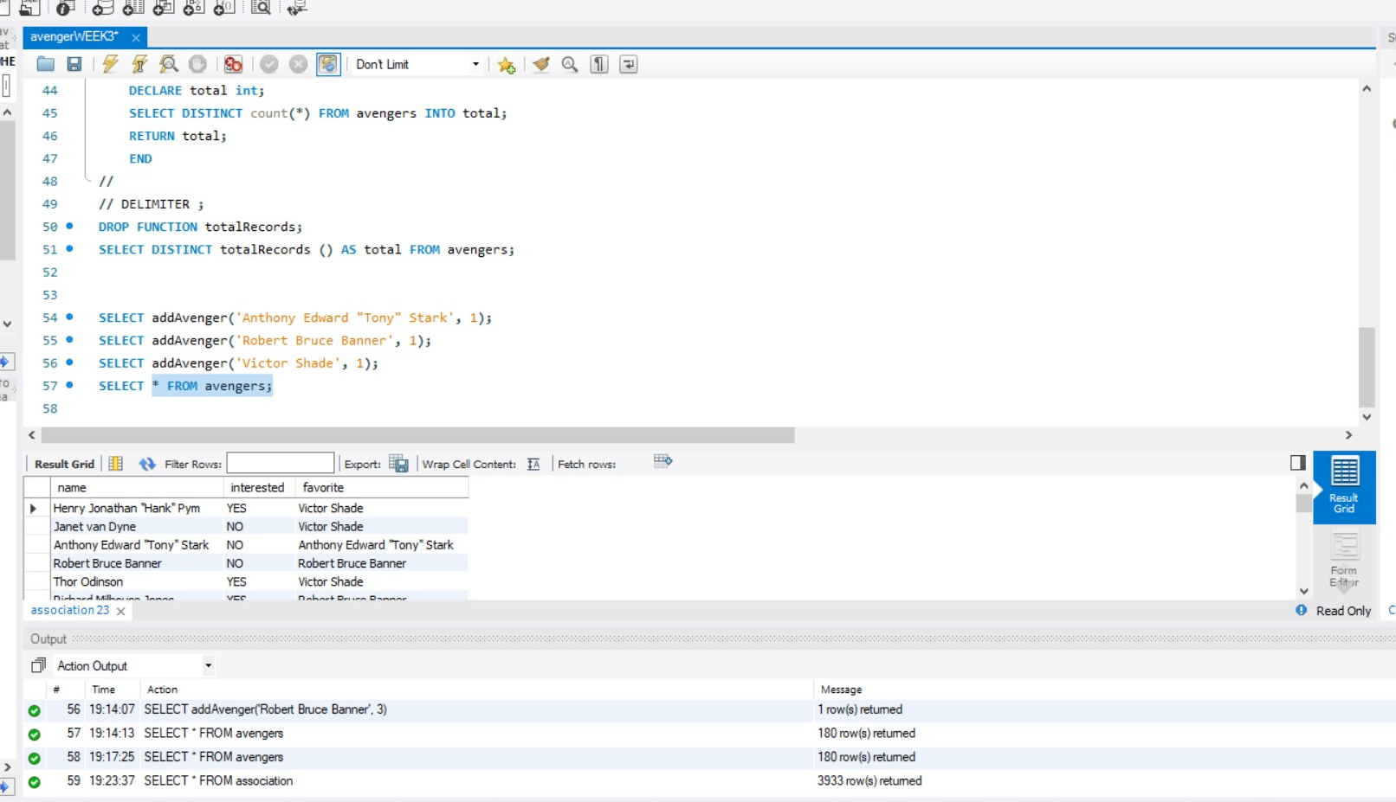

1. Remove any tables that are not the original avengers table and prove that they have been removed.

DROP TABLE association, dc_heroes

I do not have an image, did not execute query in case of resubmit.